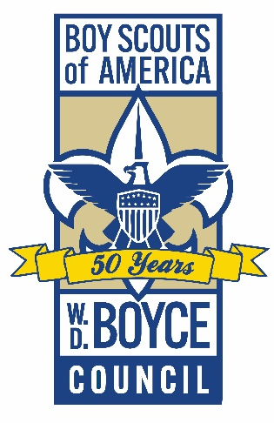
FOR IMMEDIATE RELEASE FOR INFORMATION CONTACT:
Ben Blumenberg, Scout Executive
614 NE Madison Ave
Peoria, Illinois 51503
309-673-6136, ext. 127
Ben.Blumenberg@scouting.org

W. D. BOYCE COUNCIL CELEBRATES
50 YEARS OF SCOUTING IN CENTRAL ILLINOIS
(Peoria, Illinois June 8, 2022) The W. D. Boyce Council, Boys Scouts of America, is pleased to kick off its 18-month celebration of 50 years of Scouting in Central Illinois.
The coming months will be marked by events and activities that draw attention to five decades of fun and adventure that the Scouting program has given thousands of young people in the region.
“The Boy Scouts of America has been America’s premier youth development program for more than 100 years,” said Scout Executive Ben Blumenberg. “Now more than ever, young people need the outdoor adventure, leadership and values of Scouting. We look forward to celebrating our past while continuing the journey that has made Scouting as vital today as it has ever been.”
Numbers tell a powerful story of youth development success in the W. D. Boyce Council. Since 1973, the council has served approximately 200,000 youth, with 6,300 achieving the rank of Eagle Scout. Scouts have performed an estimated 1.7 million service hours in communities across 14 counties, everything from food collection to historic preservation and conservation.
The W. D. Boyce Council was formed in 1973 from the merger of three regional councils — Creve Coeur Council (established in 1929 and based in Peoria), Starved Rock Council (established in 1926 and based in Ottawa) and Cornbelt Council (established in 1937 and based in Bloomington).
The new council’s name was chosen to recognize the Ottawa, Illinois, newspaper publisher, William Dickson Boyce, who brought the Scouting movement to America in 1910.
The W. D. Boyce Council encompasses most of Central Illinois, from Lincoln and Clinton in the south to Ottawa and Princeton in the north, from Pekin, Peoria and Canton in the west to Bloomington and Pontiac in the east.

W. D. Boyce 50th Anniversary
Nearly 5,000 youth members and 1,800 volunteers are active in 187 units across the region. Core programs include Cubs Scouts (boys and girls grades K-5), Scouts BSA (co-ed youth 11 to 17 years old) and Venturing (co-ed youth 14 to 20 years old), along with Sea Scouting, Exploring and STEM Scouts (co-ed youth 14 to 20 years old).
“Scouting thrives because it has adapted to changing times without straying from its core values and purpose,” said Council President Jon Williams. “The W. D. Boyce Council is proud to have had such a positive impact so many young lives over the past 50 years.”
The mission of the Boy Scouts of America is to prepare young people to make ethical and moral choices over their lifetimes by instilling in them the values of the Scout Oath and Law. Scouting units are chartered in the community by local organizations such as churches, schools and community service groups. The W. D. Boyce Council provides professional program support through service centers in Peoria and Bloomington.
A volunteer committee is planning activities for Scouts of all ages, including a Klondike Derby and Council-wide Camporee in Fall 2023.
Details of 50th anniversary events and activities are at wdboyce.org/50th.

###

